Alaska Indoor Gardening Curriculum

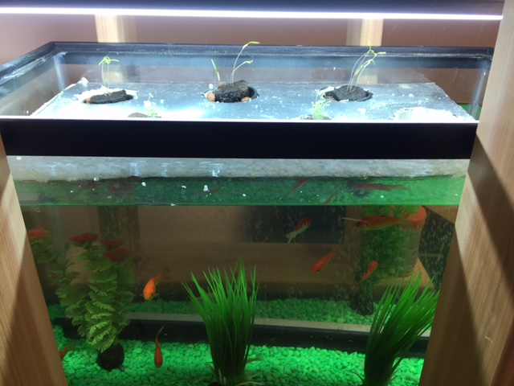
Setting Up the Aquaponic System
Author/Source: Mel Sikes, Alaska Ag in the Classroom

Suggested Grade Levels: 4th grade and up

Time: 45 minutes - 1 hour, follow up monitoring time

Teaching Goal:
To introduce students to the fun of raising edible plants indoors using an Aquaponic growing system.

Learning Objectives:
To explore the plant life cycle by building and operating an Aquaponic growing system.

Core Ideas:
- Introduction to Aquaponics (fish farming + hydroponics)
- Plant Dynamics (circulation and nutrient uptake)
- pH, Acidity, and Alkalinity Testing
- Recording Scientific Data in Tables
- Standardized Science Measurements
- Medium Scale construction of an Aquaponic System
- Drawing Conclusions from Experimentation (hands-on, observation, and note-taking)

Alaska State Science Standards: 4-LS1-1, 4-PS3-4, 5-PS3-1, 5-LS1-1, 5-LS2-1, MS-LS2-1, MS-LS2-2, MS-LS2-4, MS-ESS3-3, MS-ETS1-4, HS-LS1-2, HS-LS2-5, HS-LS2-6, HS-ESS3-4

NGSS Standards: 4-LS1-1, 5-PS3-1, 5-LS1-1, 5-LS2-1, 3-5-ETS1-1, MS-LS1-5, MS-LS2-2, MS-LS3-3, MS-ESS3-3, MS-ETS1-4, HS-LS1-3, HS-LS2-7, HS-LS4-5, HS-ESS2-6, HS-ESS2-7, HS-ESS3-4, HS-ETS1-3

Materials Needed:
- Clay Hydroponic Grow Medium or Rock Wool
- Aquarium – 20-25 gallon preferable
- Styrofoam Sheet (1-1.5 inches thick to house growing bed cups)
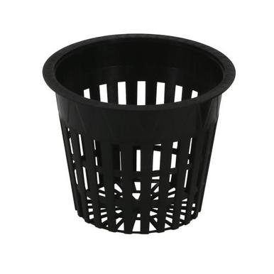
- Drill and Hole Saw bit (sized to the net pots you will use)
- 8-10 Hydroponic Net Pots (2” or 3”) or Small Clear Plastic Cups (6-8 oz.)
- Knife, or Pins for Root and Cup Holes (If using plastic cups: adult portion or prepare before class…)
- Pencils
- Popsicle Sticks
- Sharpies
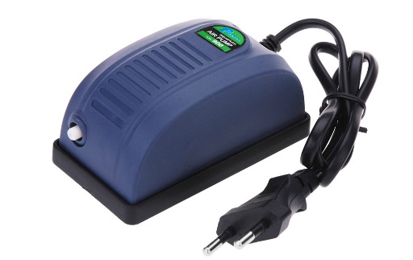
- Grow Light and Stand, suggest T-5 or LED grow spectrum lights
- Water
- Spray Bottles
- Aquarium Rocks
- Plant Seed (lettuce or herbs but possibly peas too)
- Goldfish (amount relative to tank size and fish size: recommended 1” of fish/gallon)
- Fish tank air pump (size dictated on the box by size of your tank)
- Fish tank airstone with hose to connect to air pump
(recommend the ones that are held in plastic see pic
- Dark paper (to block out 3 sides of aquarium if using aquarium to prevent algae.
- Plant Growth and Root Growth Monitoring Charts

Vocabulary:
- Acidity: The level of acid in substances such as water, or soil
- Algae: Algae is an informal term for a large diverse group of photosynthetic organisms which are not necessarily closely related
- Alkalinity: The ability of water to neutralize acid or to absorb hydrogen ions.
- Aquaponics: Aquaponics is the raising of fish and plants in a recirculating ecosystem. The fish provide nutrients for the plants. Bacteria and plants help to clean the water for the fish.
- Hydroponics: A method of growing plants in water without soil. The water must be enriched with nutrients and the plants need some type of inert medium to support the root system.
- Medium: Substance or material in which something exists or grows, from the soils and other materials for plant growth.
- Nutrients: Plants must obtain the following mineral nutrients. They need nitrogen, phosphorus, potassium, calcium, sulfur, and magnesium.
- Oxygen: A reactive element that is found in water, rocks, and free as a colorless, tasteless, odorless gas which forms about 21% of the atmosphere. Oxygen is capable of combining with almost all elements, and that is necessary for life and is also a by-product of the photosynthesis process.

- pH: Stands for power of hydrogen, which is a measurement of the hydrogen ion concentration in the plants. Plants grow best in a slightly acidic pH range of 6 to 7.
- Roots: A very important part of the plant. A root’s four major functions are: absorption of water and inorganic nutrients, anchoring the plant, storage of food and nutrients, and vegetative reproduction

Background for Teachers:
Hydroponics is a word based the combination of an English word and a Greek Word. Hydro (English) = Water. Ponos (Greek)=Work. Basically, it means “making water work for you”.

Aquaponics is the combination of aquaculture (fish farming) and hydroponics (growing plants in media other than soil). While commercial aquaponics is a multi-million dollar industry, the basic principles and equipment remain easily transferable to the classroom.

The standard aquaponics unit works by creating a nitrogen cycle. Water is shared between a fish tank and grow beds. In the fish tank, fish produce waste that is high in ammonia content. Bacteria process it into an extremely rich fertilizer that’s high in nitrogen. The vegetables extract the nitrogen from the water, making the water safe for reintroduction to the fish tank. This cycle repeats over and over, with the fish providing the basic nutrition for bacteria, the bacteria providing nutrition for plants and plants acting as a bio-filter for the fish.

The fish and plants you select for your aquaponic system should have similar needs as far as temperature and pH. There will always be some compromise to the needs of the fish and plants but, the closer they match, the more success you will have. As a general rule, warm, fresh water, fish, and leafy crops such as lettuce and herbs will do the best. In a system heavily stocked with fish, you may have luck with fruiting plants such as tomatoes and peppers.

Fish that do well in aquaponic systems:  - Goldfish  - Koi  - Angelfish  - Guppies  - Tetras  - Swordfish  - Mollies  Plants that will do well in any aquaponic system:  - Any leafy lettuce  - Pak choi  - Kale  - Swiss chard  - Arugula  - Basil  - Mint  - Watercress  - Chives  - Most common house plants | Plants that have higher nutritional demands and will only do well in a heavily stocked, well established aquaponic system:  - Tomatoes  - Peppers  - Cucumbers  - Beans  - Peas  - Squash  - Broccoli  - Cauliflower  - Cabbage

Procedure:
- Start class off by showing the students a diagram of the system we will be setting up. Then tell them step by step instructions on how we will assemble the system together.

- Organize students into groups of 2-3 and assign duties to groups: putting medium into cups, putting holes in cups for roots (if using plastic cups), putting holes in the Styrofoam, setting up the aquarium and adding water to it, etc.

- Cut the Styrofoam float to fit the opening of the tank. Cut the float a little smaller than the opening so that it won't bind up when the water level changes.

- Measure the cups opening diameter first by placing opening side down on the Styrofoam, trace with the sharpie. Draw another circle slightly smaller on the inside of the traced circle with the sharpie.

- Cut the holes in the float to the proper size for the plastic cups or plant pots that you are using. Note: you want the bottoms of the cups to hang below the bottom of the float but not fall through. If you are using plastic cups: cut several holes (approx. 1/8" to 1/4" dia.) in the bottom of your plastic cups.

- Add growing medium to the cup or plant pot. Note: if the growing medium falls out through the holes you can put a small piece of non-metal window screen or small piece of cloth over the holes before adding the growing medium. The medium mixture should be either Clay Grow Medium or Rockwool to help improve capillary action and drainage.

- Assign groups to planting pots and have those groups plant seeds in the medium. Have them write what the plant is on a popsicle stick and insert it into the medium away from the planted seed on the side of the cup. Names can be written on them as well if there is space. We should be able to do 4-6 cups depending on size of aquarium/tote and cups. They can range in size from 6-12 oz.

- Add pre-washed and rinsed aquarium stones to the bottom of the aquarium or tote.

- Attach free end of tubing to air pump and plug in air pump to outlet, make sure that there are bubbles coming from the air stone. Set the airstone in the bottom of the aquarium or tote, sitting on top of the aquarium rocks. Note: NEVER submerge the air pump in water as electrical shock could occur.

- Fill the aquarium or tote with measured room temperature water to 3-4 inches below the rim of the container.

- Place the floating platform on top of the water. Plug in and turn on the airstone pump.

- Wait at least a few days with the tank running before adding the goldfish to be sure the pH is correct. Check the pH daily and record level.

- Have students tape on dark construction paper to the back, left and right sides of the aquarium if aquarium is being used. Once everything is completed, plug in the air stone and turn on the grow light.

- Weekly/daily maintenance will be required including adding water and nutrients, pH monitoring, flushing out accumulated nutrients, etc…

- Monitor plant height growth and root growth using the charts provided.

To close the activity: After creating the system, review and summarize the following concepts:
- We can grow food without soil.
- The system must have nutrients to grow healthy plants.
- It is important to monitor the system and keep the fish healthy to keep the plants healthy and growing properly.

Maintenance and Feeding Instructions
- Have student groups keep track of where they inserted their cup and have them pick a person to water the cups a couple times a week until the roots reach the water/nutrient mixture. Use spray bottle for this. Have the students measure the roots and the plants as they grow.

- Monitor pH and adjust accordingly. Be very careful to not add too much with fish in the system.

- Feed fish with fish food until the roots reach out past the net pots.

- Change water – no more than 30% at a time on a regular basis.

Extensions: Leaf Factory Lesson, Aquaponics Fish Care Lesson, Hydroponic Plant Growth Lesson.

Assessment: Consider having the students use their science journals to diagram a complete and set up aquaponics system. Ask them to label the parts of the system and write a brief paragraph on how the aquaponics system parts work together to provide for a plant’s needs. Consider offering the students a word bank to use on this science page.

References
Books:
Aquaponic Gardening: A Step-by-step Guide to Raising Vegetables and Fish Together
by Sylvia Bernstein 2011 ISBN: 978-0-86571-701-5

The Complete Idiot’s Guide to Aquaponic Gardening
by Meg Stout 2013 ISBN: 978-1-61564-235-9

Gardening Indoors with Soil and Hydroponics
by George Van Patten 2007 ISBN: 978-1-878823-32-8

How to Hydroponics by Kenneth Roberto
ISBN: 0-9672026-1-2 2014

Hydroponic Basics: The Basics of Soilless Gardening Indoors
by George F. Van Patton 2004 ISBN: 978-1-878823-25-0

Hydroponics: A Complete DIY Guide for Gardening Using Simple Steps
by Allen Dunn 2012 ISBN: 9781480236141

Websites:
Aquaponics Association: www.aquaponicsassociation.org

Foothill Hydroponics: http://www.foothillhydroponics.com/

General Hydroponics: http://generalhydroponics.com/

Hydroponics: https://hydroponics.com/

Institute of Simplified Hydroponics: http://carbon.org/

Simply Hydroponics and Organics: http://www.simplyhydro.com/system.htm

Floating Platform Aquaponic System

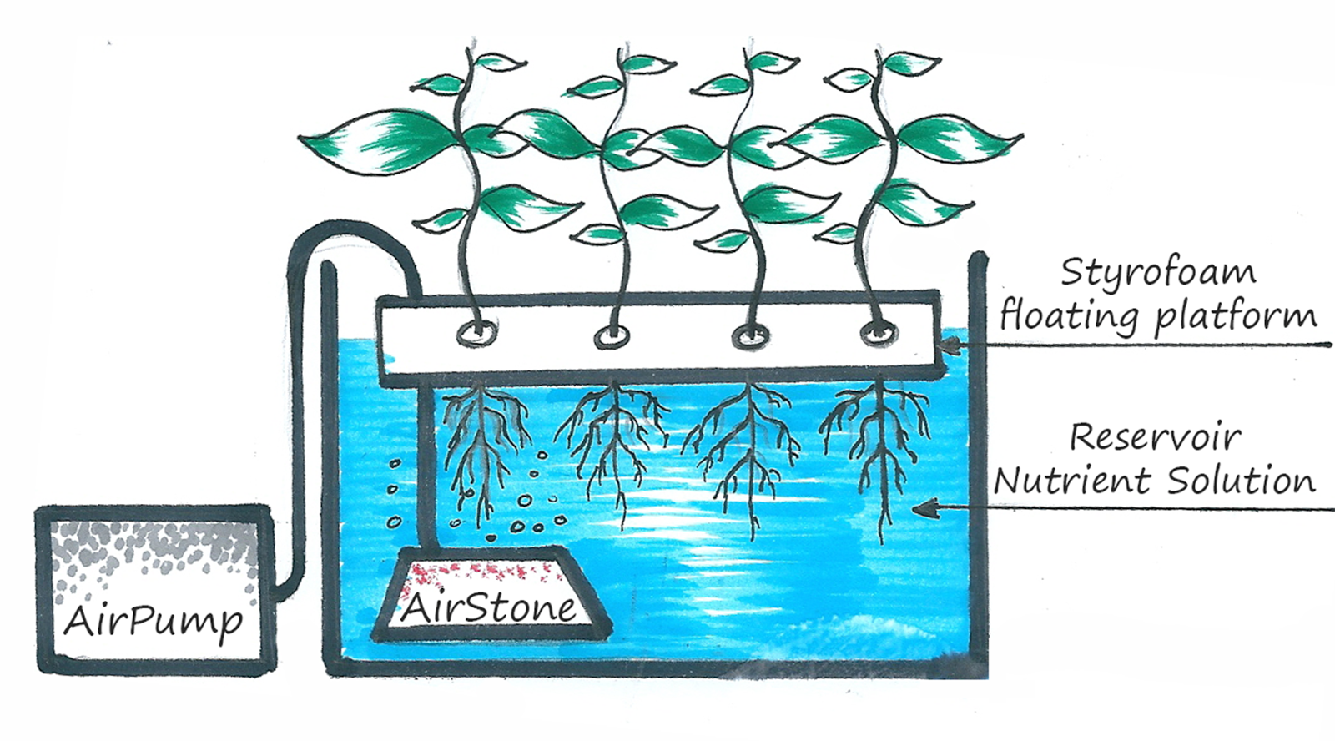

https://hydroponicsbase.com
Optional Alternative Set up:
Continuous Drip Aquaponic System

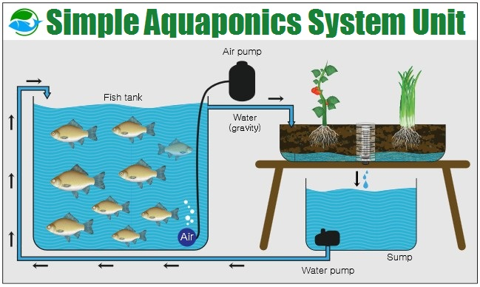
http://www.aquaponicssystemreviews.com

In this system, water is shared between a fish tank and grow beds. In the fish tank, fish produce waste that is high in ammonia content. Pumps carry this waste to the growing beds, where bacteria process it into an extremely rich fertilizer that’s high in nitrogen. All that’s left for you to do is feed the fish and decide which plants you should grow.

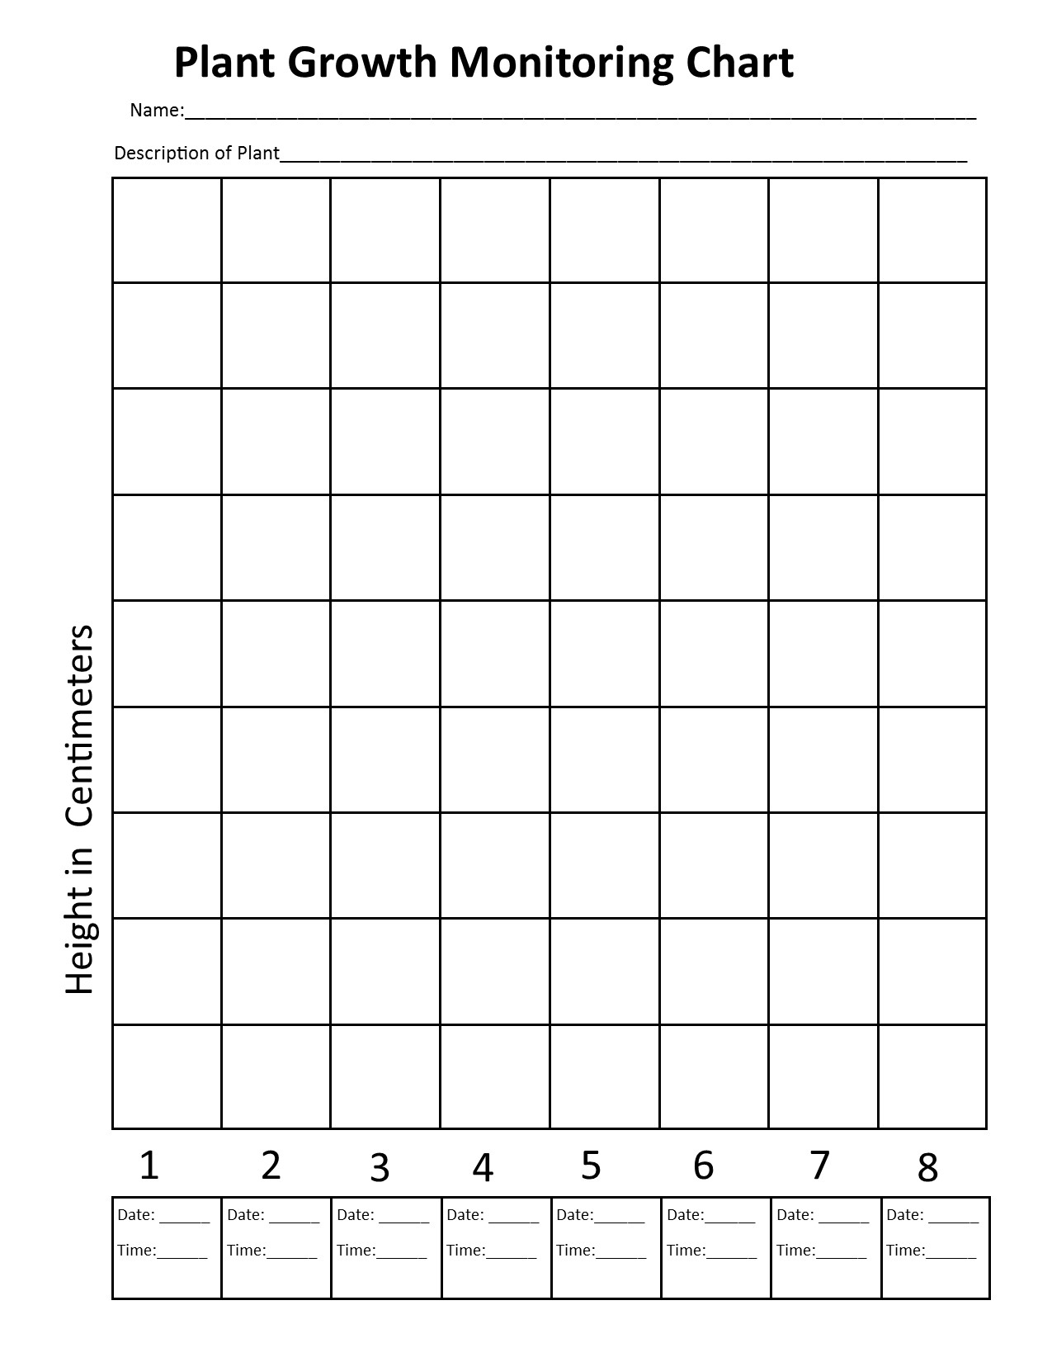
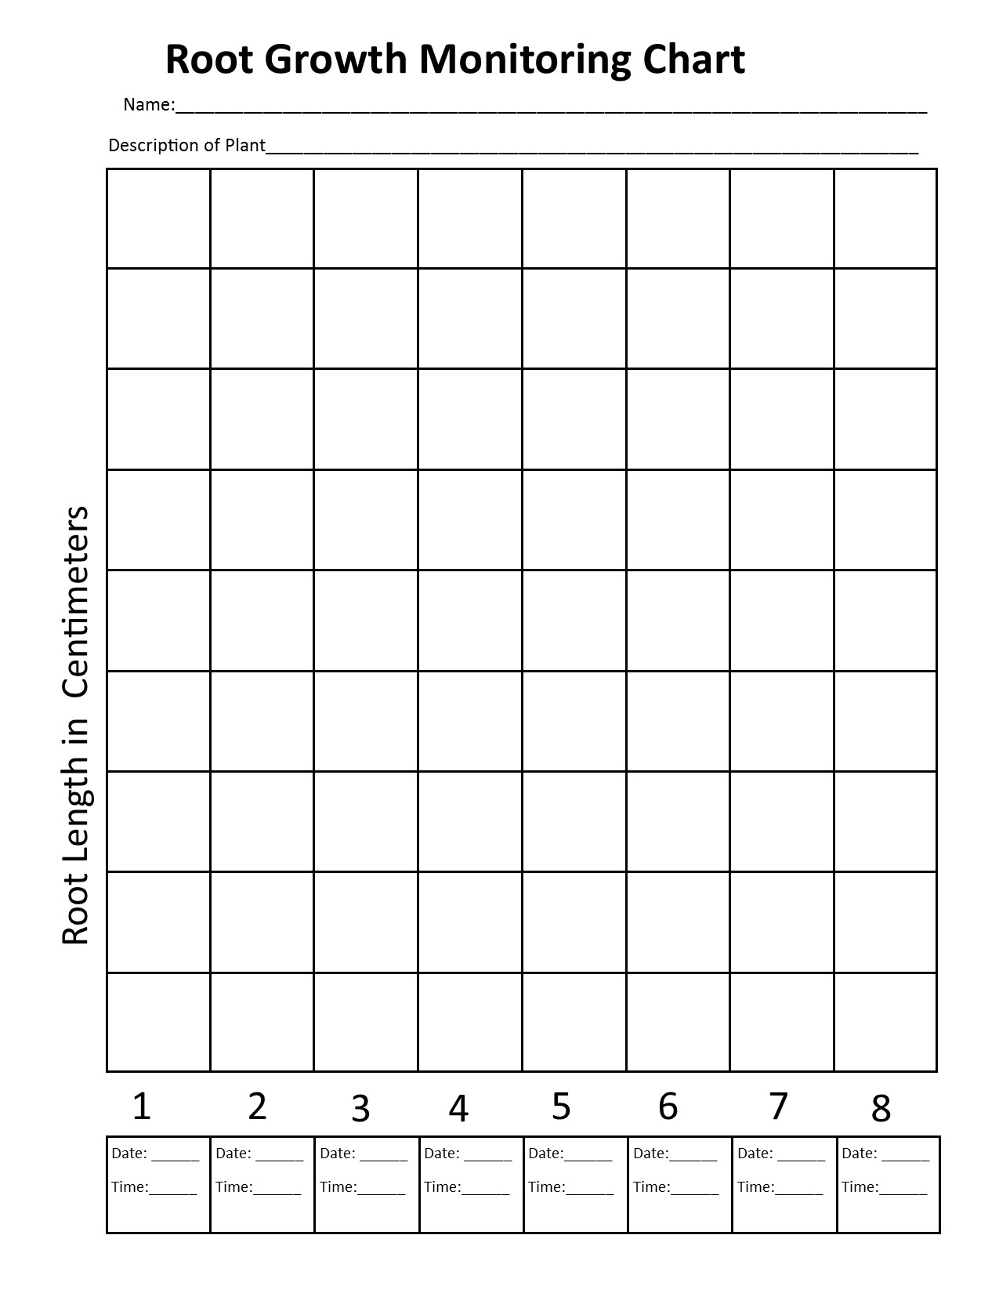
ces

